Kkkk
FOR SALE

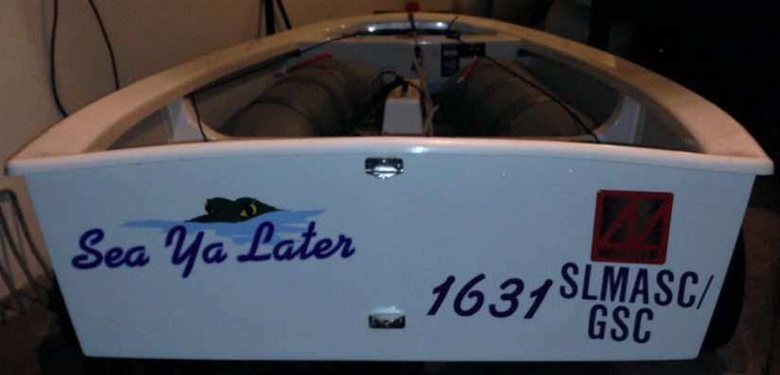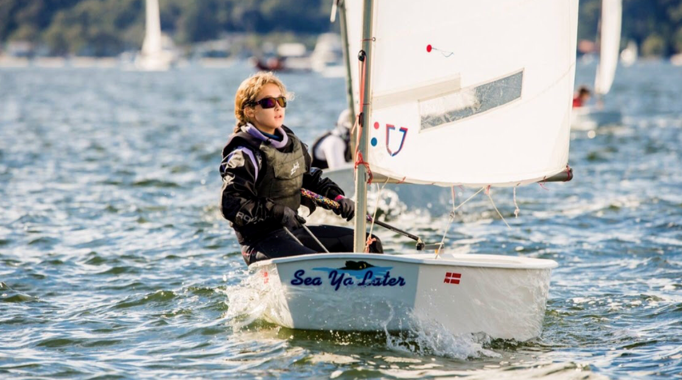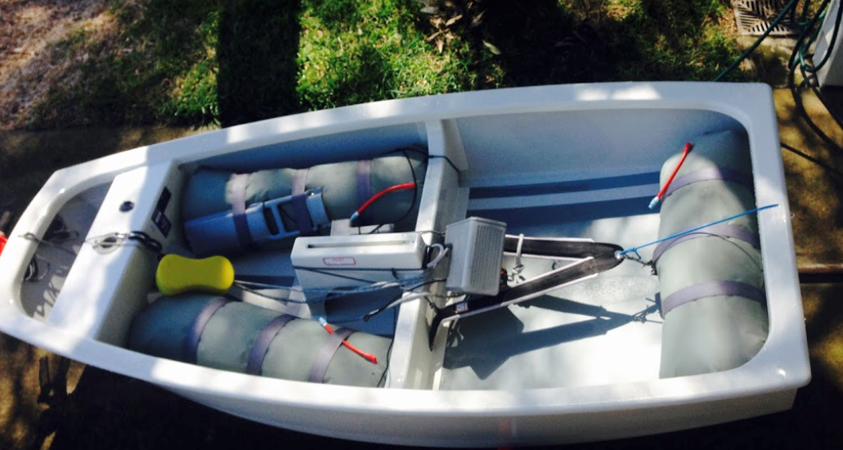

Winner Optimist
SEA YA LATER
AUS1631
$3,850
Contact Bryce Conrad
0416277348
Includes
- Beach Dolly
- Tapered mainsheet
- Winner Top and Bottom covers
- Mast clamp
- Towrope
- Wind indicator
- IODA registration, measurement book & sail certificates

- Winner Denmark 3D Star optimist hull
- Optimax MK IV Spars with spar bag
- N1 Foils with foil bag
- 2 J Sails Red, one for training & one for regattas
- 2 bailers
- 1 paddle
- 3 grey airbags

